Color scheme - Black and White (Accent colors gray, red).

GitHub Repository - <https://github.com/HeatherPetersonLMM/Personal-Portfolio>

Self-brand/logo concept -

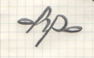

Portfolio Layout - Navigation Bar (Main, About, Gallery) , Single-paged, Display of past work, 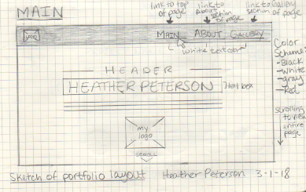Short Bio, Image, and contact information/links. Please view the three sketch concepts below.

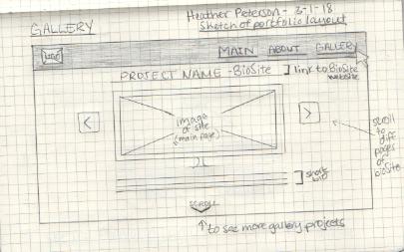

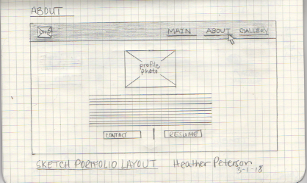

BioSite and GitHub images for gallery section

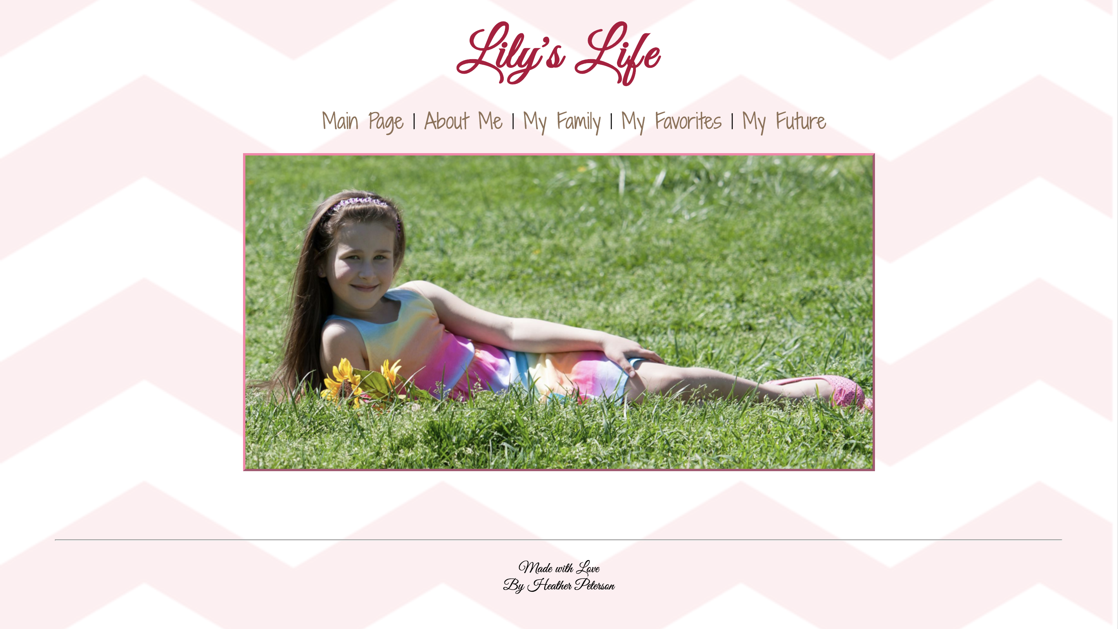

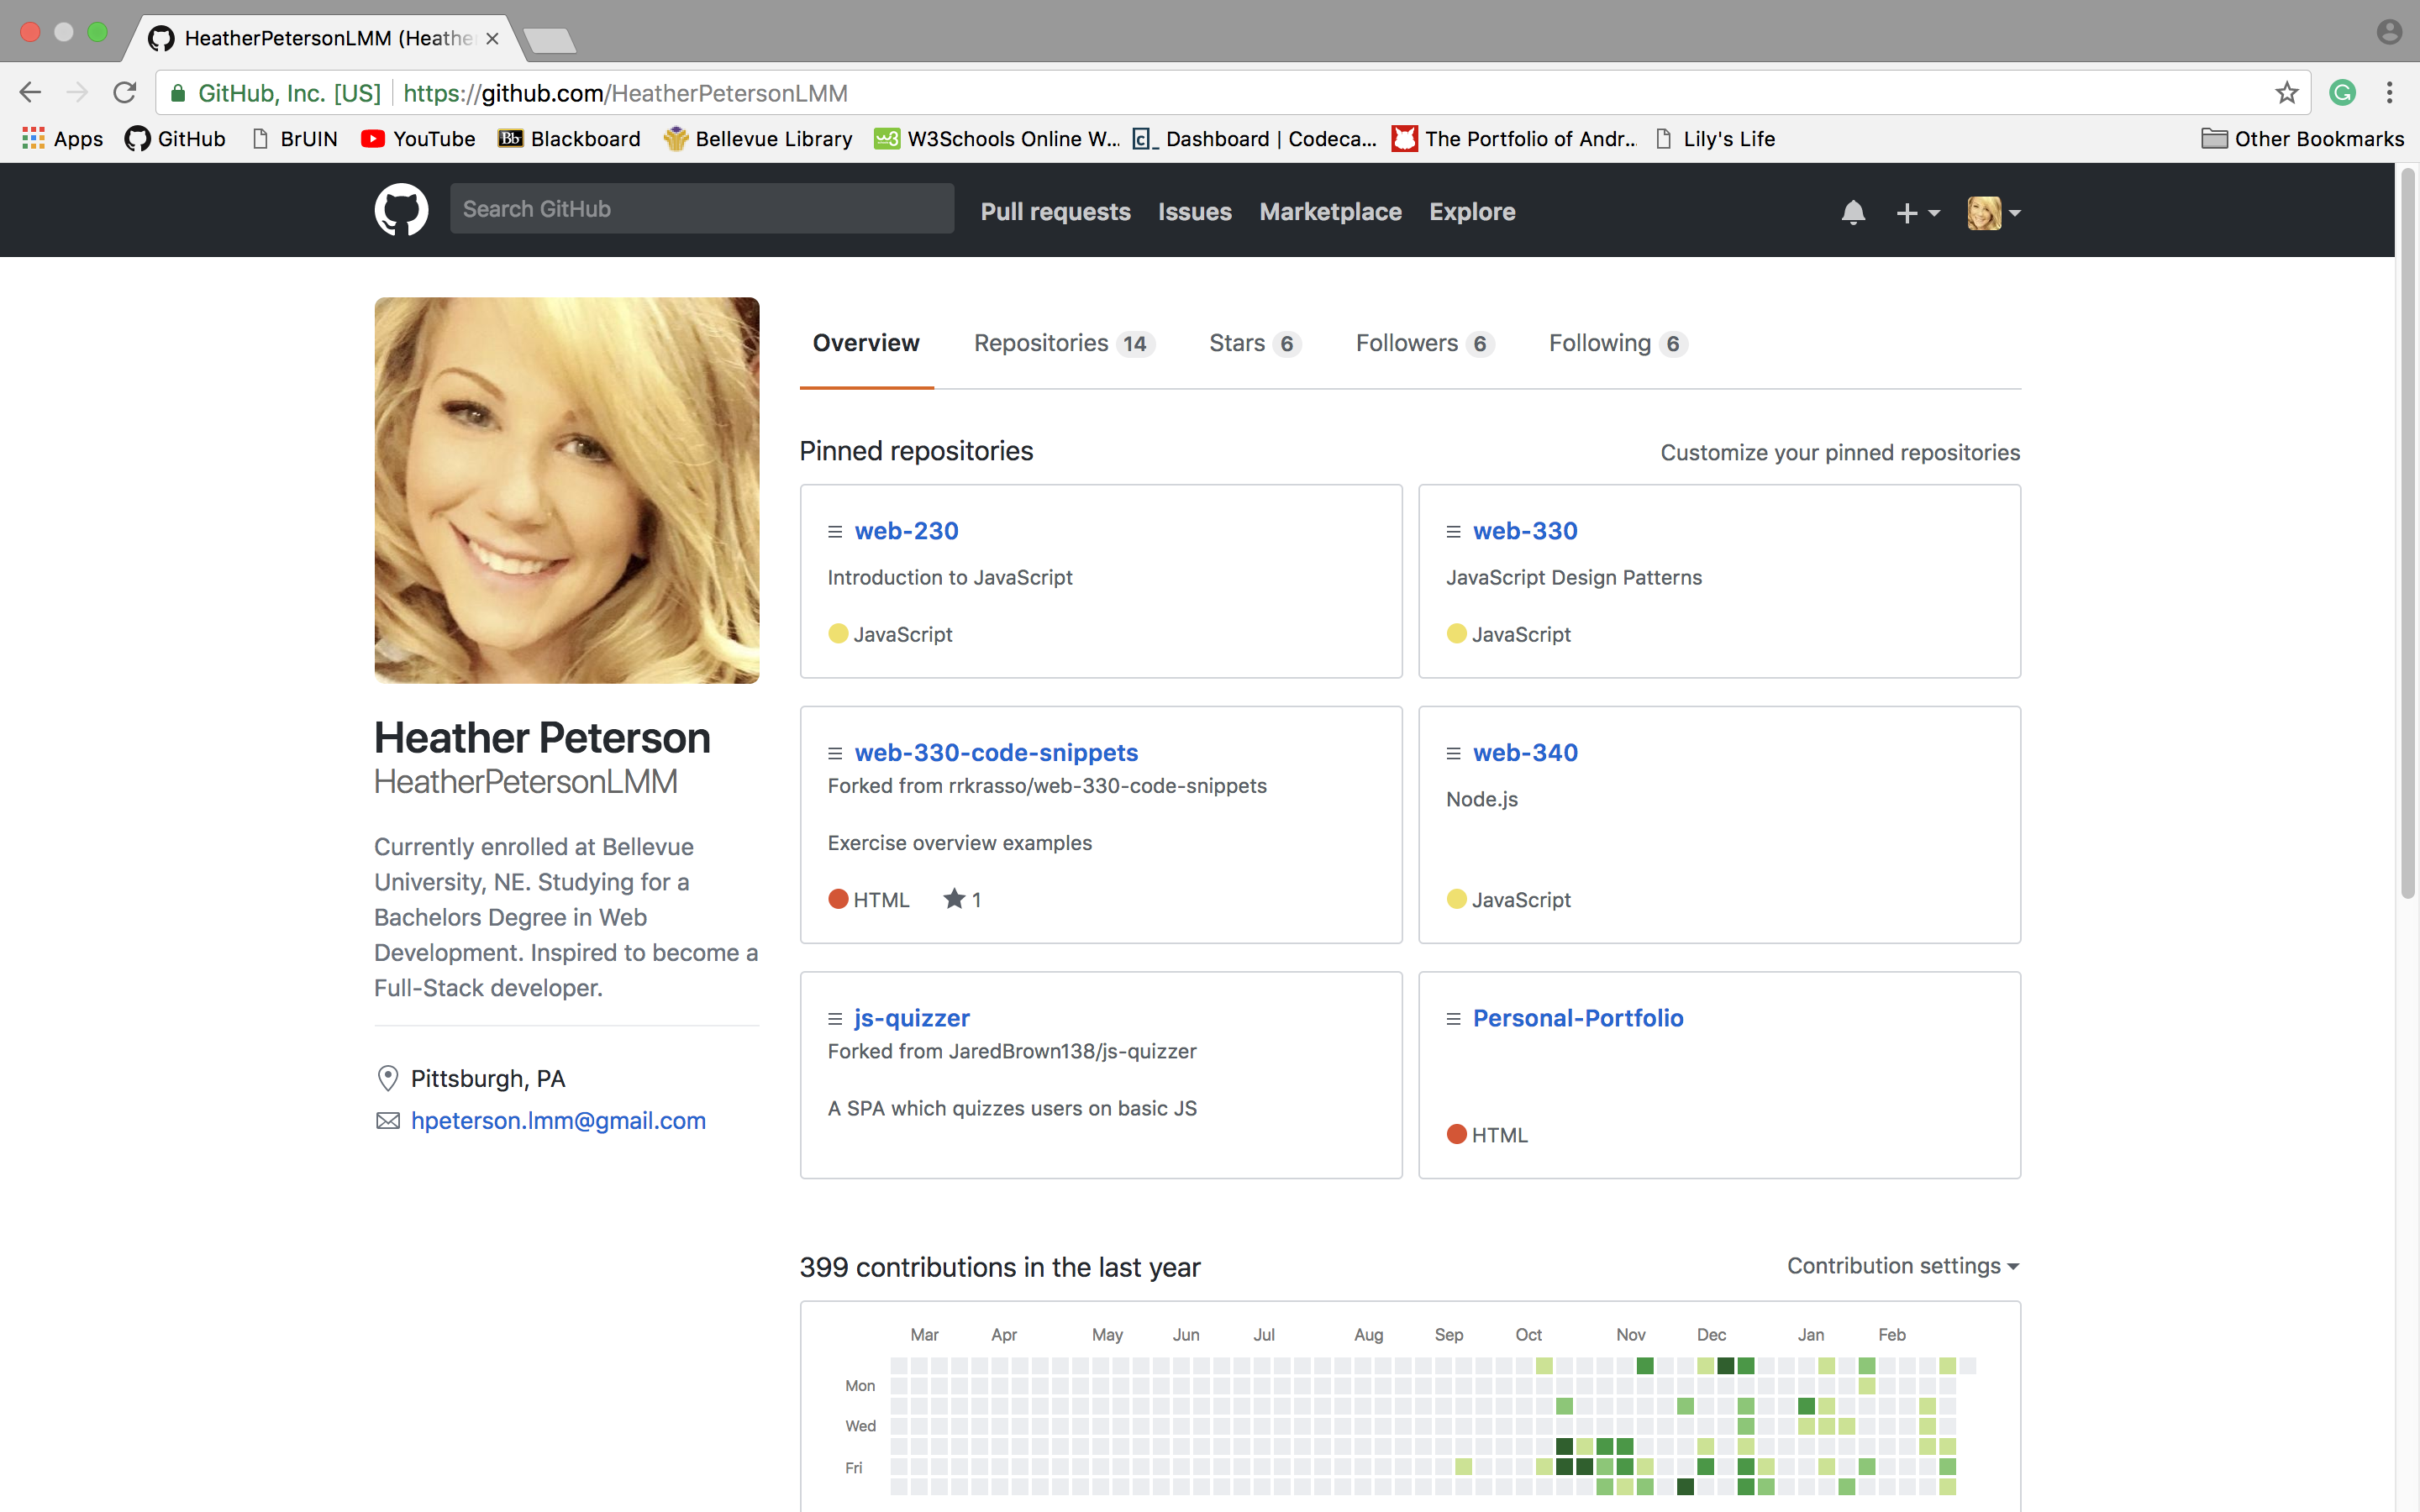

For this week’s milestone, I have developed the following for my personal portfolio. You can view all the work files on my [GitHub repository](https://github.com/HeatherPetersonLMM/Personal-Portfolio). The basic concept of my portfolio layout is demonstrated through my sketches. I’d like to have this all one paged with active links that navigate the user to the selected section(s) of the page. In the Gallery section of my page, I’d like to display screenshot images of my bioSite and GitHub websites along with any other projects. Moving forward, I plan to add more CSS coding and incorporate the JavaScript. Finalizing a basic layout in the browser is the goal by the next milestone. Thank you.